**OFFICIAL RULES FOR 2025 JPL INVENTION CHALLENGE**

The JPL Annual Invention Challenge is celebrating its twenty-sixth year. The title for this year’s contest is the **“Bucket Brigade Contest”**. The objective and rules are listed below. Questions related to this contest should be directed to: Paul MacNeal at work phone (626)788-7433 or e-mail to [paul.d.macneal@jpl.nasa.gov](mailto:paul.d.macneal@jpl.nasa.gov).

OBJECTIVE: Create a device that moves eight liters of water from a Holding Reservoir into a Bucket located 5 meters away. The winner will be the team whose device complies with all of the rules and completes the task in the fastest amount of time.

Rules:

ELIGIBILITY

1. The contest is open to all JPL employees, contractors, and immediate family members. The contest is also open to teams of students from Southern California middle schools and high schools if they have completed all required forms as outlined in rules 3 and 4 below.

REGISTRATION – JPL PERSONNEL

1. The contest is open to all JPL employees, contractors, and immediate family members. Entry forms are found on the Invention Challenge website located at <https://www.jpl.nasa.gov/jpl-and-the-community/team-competitions/invention-challenge/>. He entry forms must be filled out and submitted to Public Services prior to midnight November 8, 2025.

The badging process has been drastically changed this year. **Please pay attention to all of the information requested to be filled out on the entry form.** Email your completed entry form to [Kimberly.C.Johansen@jpl.nasa.gov](mailto:Kimberly.C.Johansen@jpl.nasa.gov). A maximum of 10 people are allowed to attend the final contest for each team. This includes students, teachers, and chaperones.Only the first 20 JPL/contractor entries will be permitted to compete.

**Every person attending the contest needs to be cleared though Security.** The team leader (or a JPL employee on the team) will fill out a request for clearance by visiting the Security link shown <https://visitor.nasa.gov/splan-ui/#myvisitor/list/1>. Each person listed on the entry form will receive an email from the Security office. Follow the instructions provided in the email. **Do not delay. Anyone who has not been cleared through the Security office by the date of the contest will not be allowed to participate.**

Additionally, for all persons invited to the final that are 18 years old or more, proper documentation of citizenship is required. For Foreign Nationals or Green Card Holders, bring a valid Passport. **For US Citizens, a Real ID is required.** **A Driver’s License without a Real ID identifier is no longer acceptable.**

REGISTRATION – SCHOOLS

1. The contest is open to all Southern California Middle Schools and High Schools. A maximum of three teams from each school can submit completed entry forms. Entry forms for student teams are found on the Invention Challenge website located at <https://www.jpl.nasa.gov/jpl-and-the-community/team-competitions/invention-challenge/>. Entry forms must be filled out and emailed to [Kimberly.C.Johansen@jpl.nasa.gov](mailto:Kimberly.C.Johansen@jpl.nasa.gov) prior to midnight October 4, 2025. Only the first 75 student teams will be permitted to compete. **IMPORTANT:** Teams are limited to a maximum of 10 people. This includes students, teachers, and chaperones.

Video Release forms for every person (student, teacher, chaperone) are required to attend the Final Contest at JPL. Due to logistics issues, please fill out the Video Release forms as soon as possible but no later than November 3, 2025 and mail them (not email) **to Public Services at Jet Propulsion Laboratory, M/S 186-113, 4800 Oak Grove Drive, Pasadena, CA 91109. Please put your Entry Number on the forms if you know it.**

Questions regarding the entry forms can be directed to [Kimberly.C.Johansen@jpl.nasa.gov](mailto:Kimberly.C.Johansen@jpl.nasa.gov) in Public Services at (818)354-2413.

SPECIAL RULES FOR SCHOOL TEAMS

4) Student teams will compete at a regional competition held on Saturday, November 8, 2025 at either Augustus F. Hawkins High School in Los Angeles or Costa Mesa High School in Orange County. **Please note that this is 2 weeks earlier than last year’s contest due to paperwork processing issues encountered last year.**  Details for the regional competitions will be sent to all registered teams. The top five teams with the fastest completion times from each regional competition will be invited to compete at the JPL contest held on Friday, December 5, 2025 (see Rule 5 below). In addition, the next 10 teams with the fastest completion times between both regional competitions will also be invited to compete at the JPL contest.

The badging process at the Final Contest has been drastically changed this year. If your team is invited to the Final Contest and there are any changes to your entry form, the updated entry form must be emailed to [Kimberly.C.Johansen@jpl.nasa.gov](mailto:Kimberly.C.Johansen@jpl.nasa.gov) no later than November 10, 2025. For each team that is invited to the Final Contest held at JPL, every person listed (students, teachers, and chaperones) on the entry form will receive an email from the Security office. Follow the instructions provided in the email. **Do not delay. Anyone who has not been cleared through the Security office by the date of the Final Contest will not be allowed to participate.**

Additionally, for all persons invited to the final that are 18 years old or more, proper documentation of citizenship is required. For Foreign Nationals or Green Card Holders, bring a valid Passport. **For US Citizens, a Real ID is required.** **A Driver’s License without a Real ID identifier is no longer acceptable.**

**Please note that the Video Release forms should have been submitted prior to the Regional Contest per Rule 3. Anyone who has forgotten to send in a completed Video Release Form prior to November 3, 2025 must mail it to Kim Johansen no later than November 13, 2025.**

LOGISTICS

1. The date and time for the final contest is Friday, December 5, 2025 between 11:30 AM and 1:00 PM. The contest is held at the Jet Propulsion Laboratory, 4800 Oak Grove Drive, Pasadena, CA 91109. The contest area is located in front of the Administration Building (Bldg. 180) steps. The event will be held in the Mall area even if there is rainfall. Check-in for the event will begin at 10:15 AM.

DEVICE RULES

1. The device must have the following characteristics:
2. The device is a mechanical system that propels water from a Holding Reservoir (see Rule 7) and deposits eight liters of water into a Bucket (See Rule 8) located 5 meters away from the center of the reservoir in less than 60 seconds.
3. The device may pick up water out of the reservoir such that no more than 2.0-liters of water are being lifted up at any time. **A violation of this rule will result in disqualification.** The method(s) of picking up water will be discussed at check-in and the volume of water will be verified to be less than 2.0 liters at any time. One or more water holders can be used to achieve the maximum of 2.0 liters of water. Questions related to how to measure the volume of water being picked up should be addressed to the contest organizer.
4. The device may not touch any part of the side of the Holding Reservoir at any time before, during, or after the event. The device cannot rest on the bottom of the Holding Reservoir. The device may incidentally touch the bottom of the Holding Reservoir but cannot scratch or otherwise damage the Holding Reservoir.
5. The device must allow the Bucket to be seen so that water can be observed entering the Bucket and eventually exiting through the hole in the side of the Bucket. The hole in the side of the Bucket is located in the back of the Bucket (away from the Holding Reservoir).
6. The device must stay away from the Bucket by at least 5 cm in all directions. No part of the device can enter inside the Bucket volume.
7. The device must have a single operation to initiate “lift” operations of the water out of the Holding Reservoir. Multiple lift operations will be necessary. Autonomous lift operation systems are allowed. Examples of the single operation include pulling a pin, pushing a button, releasing a latch, etc.
8. The device can occupy space anywhere within the set-up area (See Rule 9) that is 7 meters by 2 meters as shown in Figure 1. The device must remain within the set-up area before, during, and at the end of the event. There is no height limit.
9. **The device cannot use any suction device or pump.** For this contest, a pump is defined as any device that can move water using a vacuum or suction action. This rule will be strictly enforced. Energy methods that may be construed as suction devices or pumps must be cleared by Paul MacNeal prior to being used in the device.
10. The device will contain energy method(s) to propel the water out of the Holding Reservoir, move the water towards the Bucket, and eventually pour the water into the Bucket. The choice of energy system is optional but has a few restrictions. No human energy can be applied to move any portions of the device or water during the event. One allowed exception is that potential energy devices are allowed to be reset prior to the initiation of the potential energy device involved in each of the water lift operations. The potential energy device may not be reset while still lifting water. The energy methods must be safe to the team and all observers. Unsafe methods of energy, as determined by the contest organizer, will not be allowed to compete. A powered extension cord will be available. Some examples of disallowed energy methods include explosive reactions, chemical conversions with toxic by-products, and unsafe high-pressure air systems. If air compressors are used in the device, it will need to be approved by the Safety team at JPL prior to their use at the regionals or at the finals. Approval can be obtained by submitting the request to the contest organizer. **Questionable energy sources must be approved by Paul MacNeal prior to November 7, 2025.**
11. The device must be adaptable to non-level surfaces (described in Rule 9) and will need to be able to operate either from Area 1 or Area 2 which will be determined just prior to setting up.
12. SPECIAL RULE FOR SCHOOL TEAMS ONLY: To avoid plagiarism, each team that competes at the regional contest will have photographs taken of their device. The basic concept of the device (energy source and size) must be maintained between the Regional Contest and the Final Contest. Minor modifications to the device are allowed within these constraints.
13. SPECIAL RULE FOR SCHOOL TEAMS ONLY: For any school or organization that submits more than one entry, each device is required to be substantially different from all other devices. Devices must attempt to use different energy sources. Contact Paul MacNeal regarding specific questions for this rule.

HOLDING RESERVOIR

1. The officially supplied Holding Reservoir is described below. The Holding Reservoir rests on the ground (even with a slight slope). It will be filled with water to within 3 cm of the top of the lip of the reservoir at its lowest point (remember that the contest area is on a slight slope). The estimated amount of water in the reservoir is over 50 liters of water at the start of the event. Water will not be refilled during the 60-second operation.

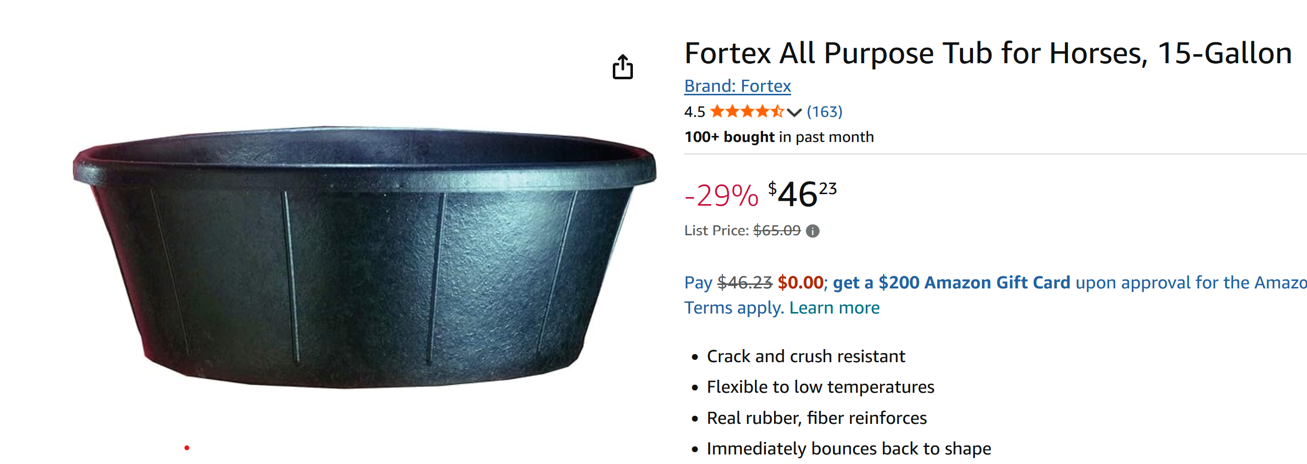

This tub is available from Amazon, as indicated above. The inside dimension of the tub is approximately 23.0” in diameter at the top and is 19” in diameter at the bottom. It measures to be 9.25” tall.

BUCKET

1. The Bucket holds more than 3.5 gallons of water. The Bucket rests on the ground (even with a slight slope). A hole with a screen guard will be drilled at the correct height to indicate when the level of water inside the Bucket is at 8-liters. When water streams out more than just a drop or two, the clock will be stopped and the event will be over. The decision of the referee is final. The height of the hole will be 6.0” [TBC] above the ground. The overall dimensions of the Bucket are 11.9” in diameter at the top of the Bucket and 10.18” tall. This tub is available from Amazon, as indicated below.

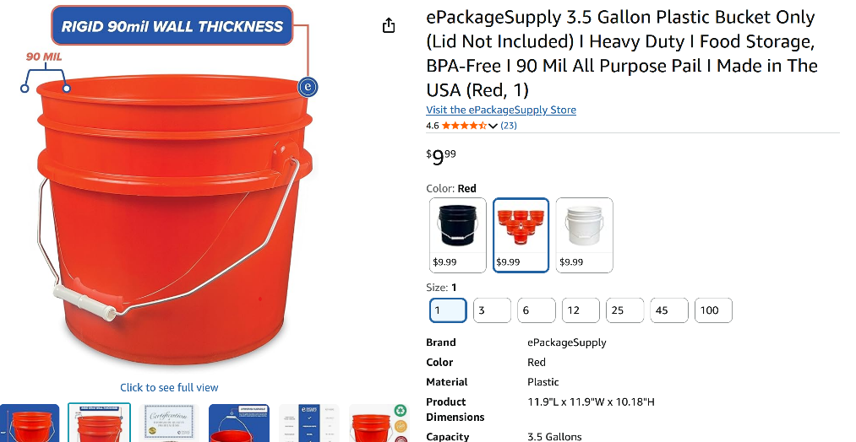

CONTEST AREA DESCRIPTION

1. The contest site is in front of the steps leading to Building 180. The site will contain two areas for setting up and operating the device. The size of each device set-up area is 2 meters by 7 meters as shown in Figure 1. Each team will be randomly assigned to either set-up area. The ground is concrete with a rough finish and has a slight slope (approximately 1 degree across the width as shown in Figure 1).

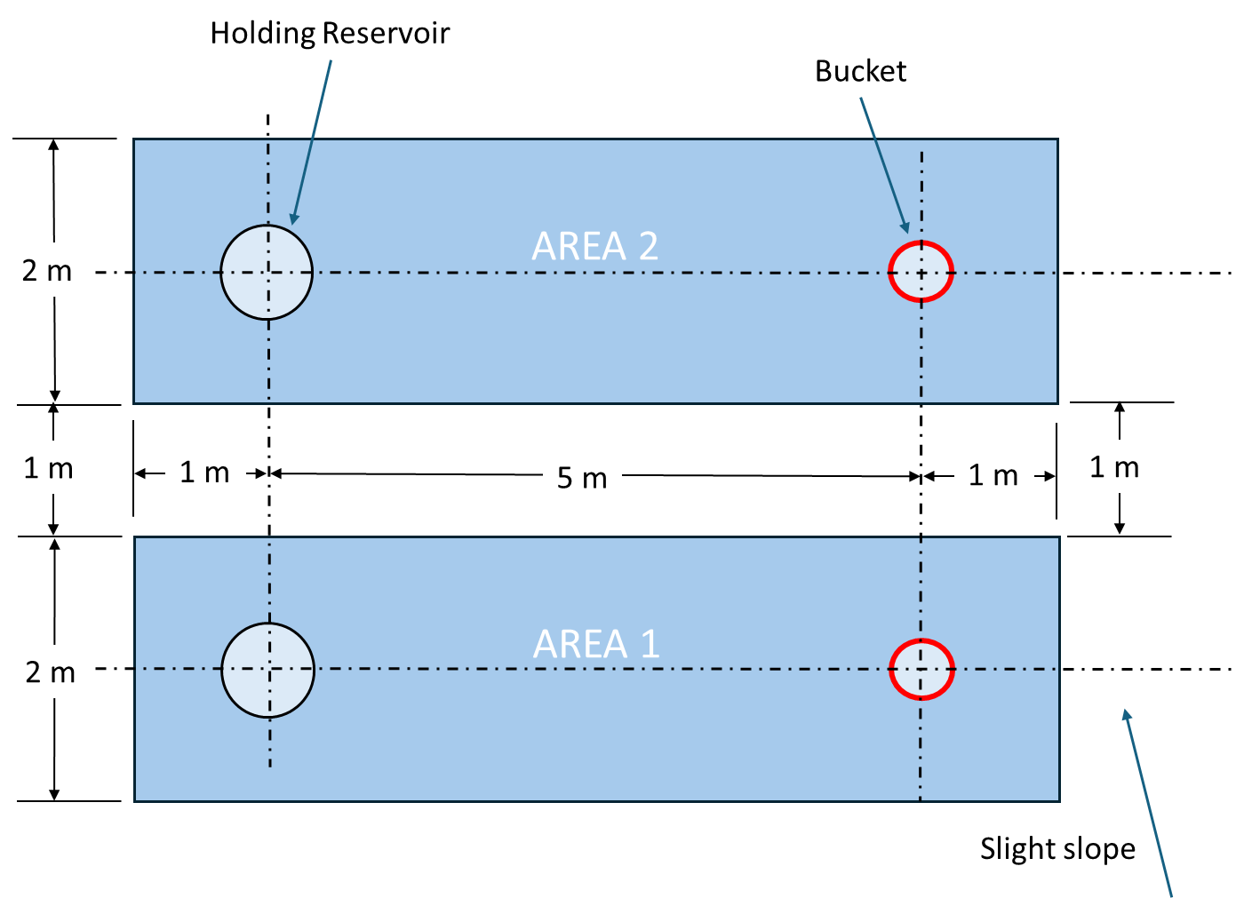

**FIGURE 1. Contest Area**

CONTEST PROCEDURE

1. The order in which teams will participate is selected by a random process. The team will be given a three-minute period to set up their device. Safety advisors will be observing the team during their setup time and will warn and potentially stop the team if any setup operations can lead to potential accidents. If the safety advisor stops the set-up, the time that the team is stopped will not count against the three-minute set-up period. Strict time limits will be imposed to ensure that all teams are able to operate their device.

Each team shall designate a speaker that is **not involved with the device setup** to talk about their team and their device during the setup period. The team will be asked if they are ready to proceed. The referee will ensure that the device is within the boundaries as defined in the rules.

The procedure for running the event and determining the official point total is as follows:

1. The referee will give a countdown (3...2...1...GO!) for the start of operation for the device.
2. The timers will start the time at the referee’s direction.
3. The area monitor will observe the event and make sure that the team does not pick up water out of the Holding Reservoir with more than 2.0-liters of water at a time. The area monitor will also observe that the device remains within the set-up area.
4. The lead timer will periodically announce how much time has transpired for the event. The lead timer will yell an audible “STOP” when 60 seconds have transpired.
5. The referee will yell an audible “STOP” when the 8-liter water level in the Bucket has been achieved.
6. The timers will compare the measured time and determine the official time that was needed to complete the event.

All teams will be asked to remove their device and place it back in their original waiting area.

The winning team will be the team whose device has complied with all of the rules and finishes the event in the fastest time. Times that are within 0.05 seconds will be considered a tie. If two or more teams are tied, each team will be asked to repeat the entire event and the same rules for declaring the winner will apply.

AWARDS

11) Trophies will be divided into two categories: JPL employees/family/contractor entries and school team entries. Trophies will be given for first, second, and third place for each category at all contests (regional contests and the JPL contest). Certificates will be issued for the most unusual, most artistic, and most creative designs only at the Final Contest.

School or JPL Name: __________________________ Team Name: _______________________

Entry Number: _____________

(leave blank until known)

**Official Scoresheet**

Is the volume of Water Picked-up at any time less than 2.0 liters? _______

Did the device remain within the Set-up Area? ______

Official Time to complete task: ______________

Comments:

Pass Safety Inspection?: Yes or No